University at Buffalo Department of Orthopaedics
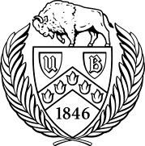
RESEARCH NEWSLETTER

Volume 4, June 2016

June A. and Eugene R. Mindell, MD Professor and Chair: Leslie J. Bisson, MD

Director of Clinical Research: John Leddy, MD

Director, Kenneth A Krackow Orthopedic Research Lab: Mark Ehrensberger, PhD

Editors: Melissa Kluczynski, MS; Sonja Pavlesen, MD, MS

Introduction

Since the last time I introduced our newsletter, a lot has happened in the Clinical Research arm of UBMD Orthopaedics and Sports Medicine. The department saw 36 studies complet-ed (to abstract or publication status) and there are 34 ongoing projects, 17 of which involve the orthopaedic residents. Members of the faculty serve as journal reviewers

(> 28 different journals) as well as journal editors, national meeting panelists, and on grant review committees. In the last academic year, there have been 45 publications in the peer-reviewed literature, 13 book chapters, 10 poster presentations, and over 50 invited presentations at national and international meetings. The department is collaborating with 10 UB and local departments, 8 national departments, and 2 international universities. Researchers in the department have won national awards, and the Concussion program was awarded a 5-year RO1 from the NIH to study the physiology of concussion. Under the leadership of Dr. Bisson, UB is a participant in a Harvard-led applica-tion for a major NIH national multicenter randomized trial to investigate the

optimal medical therapy for meniscal problems in the arthritic knee. We are also collabo-rating with other departments on internal multi-departmental projects to gather pilot data for external grant applications. We have implemented a new mentoring system to help first year residents identify a meaningful and reasonable research idea early on and ensure that they complete it prior to graduation.

None of this would be possible without the hard work and insight provided by our excellent Clinical Research Associates: Melissa Kluczynski for Sports Medicine; Sonja Pavlesen for BGMC, ECMC, and WCHOB; and Clinical Research Coordinator Mary Bayers-Thering for BGMC. They are ably aided by Research Assistants: Laura Ryan and Kathleen Lafferty. Work-ing with Dr. Anders and the residents, Laura has done excellent work improving the fracture database at ECMC. We have excellent statistical consultation, led by Dr. Jiwei Zhao of the Department of Biostatistics.

We thank our chairman, Dr. Bisson, for providing the vision and leadership to move clinical research forward and for providing the resources to help ensure that UBMD Orthopaedics

- Sports Medicine will be renowned internationally for its clinical care and research, each of which informs and improves the other. One goal for next year is to take some of the exciting projects that are underway and fashion them into grant applications to foundations and federal agencies. Finally, our success depends upon your ideas and passion to improve clinical care through the vehicle of good clinical research, and we are here to help you as much as we can. If you have ideas that will lead to a grant application for your work, please do not hesitate to contact me or the CRAs. Thank you for supporting Clinical Research at UBMD Orthopaedics & Sport Medicine.

Dr. John Leddy, Director of Clinical Research

1

Inside this issue
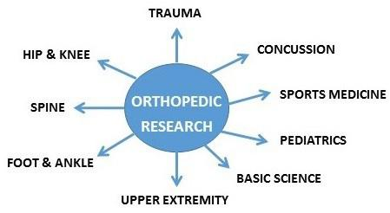

Introduction…………………….1

Residency Graduation ……….2

Funding Sources….…………..3

Recent Publications………...4-6

AAOS/ORS 2016……………..5

Recent Presentations………6-7

Epidemiology Corner…………8

Research Contacts……………8

2016 Orthopeadic Residency Graduates with Department Chair Prof. Bisson
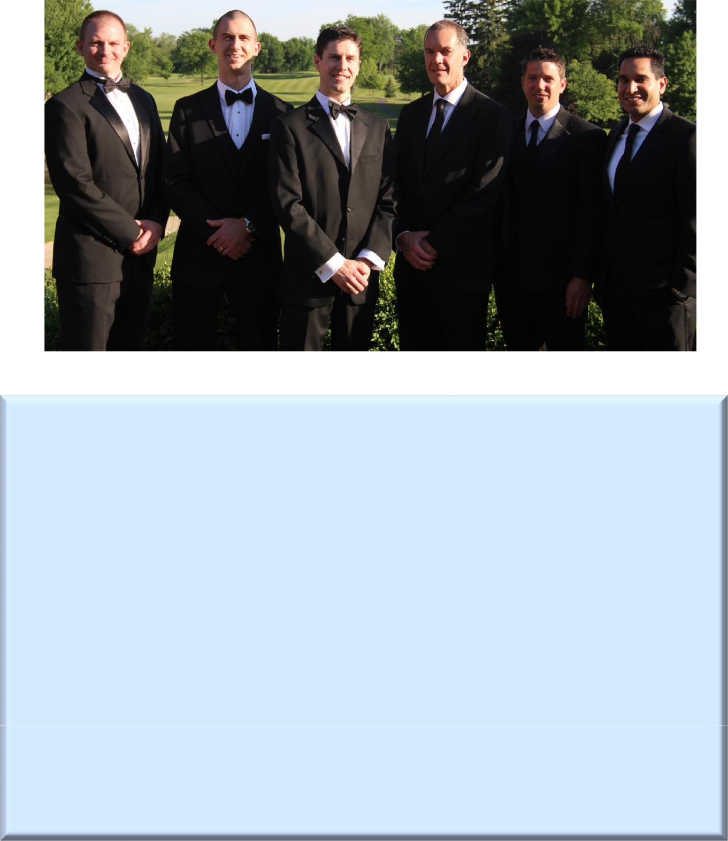

Congratulations to our graduates 2016

We would like to dedicate the 4th issue of the Research Newsletter to our 2016 orthopaedic residen-cy graduates, Drs. Matthew Binkley, Matthew Brown, Timothy Bryan, Samir Nayyar and Christopher Urband. Here is a sampling of their most recent research achievements:

Binkley, M., Fineberg., M., Section 2-10. “Glenoid superior labrum anterior to posterior (SLAP) lesions.” In Orthopedic Surgery Clerkship: A Quick Reference Guide for Senior Medical Students,

Springer Publishing, Edited by A. Daniels, A. Eltorai, and C. Eberson.

Brown, M.J., Bisson, L.J., Anders, M.A. (in press). Tibial tubercle fracture after bone-patellar ten-don-bone autograft: a case report and review of the literature. American Journal of Orthope-

dics.
Bryan, T., Duquin, T.R. Distal Humerus Nonunions / Malunions. Elbow Trauma: A Master Skills

Publication. In Press.

Kluczynski, M.A., Nayyar, S., Marzo, J.M., Bisson, L.J. (2015) Early versus Delayed Passive Range of Motion Following Rotator Cuff Repair: A Meta-analysis. American Journal of Sports Medicine,

43(8): 2057-2063.

Urband, C., Duquin, T.R. Sternoclavicular Joint Injury. Shoulder and Elbow Trauma and its Com-plications I: The Shoulder. In Press.

Research Funding Sources/ Grant Deadlines 2016/ 17

OREF Resident Research Project Grant

Funds: Up to $5,00/ 1 year Deadline: Sept 1, 2016 Midnight CST
https://proposalcentral.altum.com/Opportunities.asp?GMID=143

OREF/ Career Development Grant

Funds: Up to $225,000/ 3 years Deadline: LOI Aug 15 and Grant Sept 13, 2016 Midnight CST https://proposalcentral.altum.com/Opportunities.asp?GMID=143

OREF/ New Investigator Grant

Funds: Up to $50,000/ 1 year Deadline: LOI Aug 15 and Grant Sept 13, 2016 Midnight CST https://proposalcentral.altum.com/Opportunities.asp?GMID=143

OREF/ ASES Rockwood Clinical Research Grant in Shoulder Care
Funds: Up to $50,000/ 1 year Deadline: Sept 13, 2016 Midnight CST

https://proposalcentral.altum.com/Opportunities.asp?GMID=143

OREF/ Goldberg Arthritis Research Grant
Funds: Up to $50,000/ 1 year Deadline: Sept 13, 2016 Midnight CST
https://proposalcentral.altum.com/Opportunities.asp?GMID=143

OREF/ Prospective Clinical Research Grant

Funds: Up to $150,000/ 3 years Deadline: LOI Aug 15 and Grant Sept 13, 2016 Midnight CST https://proposalcentral.altum.com/Opportunities.asp?GMID=143

OREF/ MTF Research Grant
Funds: Up to $98,000/ 2 years Deadline: Sept 13, 2016 Midnight CST
https://proposalcentral.altum.com/Opportunities.asp?GMID=143

ASES Research Grant

Funds: Up to $20,000 Deadline: 9/8/16
http://www.ases-assn.org/?p=physic-grants

OTA Resident Research Grant Opportunities
Funds: Up to $20,000 Deadline: July 5, 2016 Midnight CST
http://ota.org/research/research-grant-opportunities/

OIF Investigator Travel Grant

Funds: limited Deadline: Applications available Fall 2016
http://www.oif.org/site/PageServer?pagename=RS_GrantApp

UB Innovative Micro-Programs Accelerating Collaboration in Themes (IMPACT)

Funds: $35,000 Deadline: 10/16/16 by 5p.m.
http://www.buffalo.edu/research/research-services/find-funding/find-ub-funding/current--annual-and-ongoing-funding/impact-funding.html

The Kenneth A. Krackow Orthopaedic Research Laboratory has Moved!

The Kenneth A. Krackow Orthopaedic Research

Laboratory has moved from Farber Hall to the Biomedical Research Building (3435 Main St., 4th Floor, Buffalo, NY 14214).

Recent Publications

Peer-Reviewed Articles:

Anderson, M., Browning, W., Urband, C., Kluczynski, M.A., Bisson, L.J. (2016). A systematic summary of systematic reviews on the topic of the anterior cruciate ligament. Orthopaedic Journal of Sports Medicine, 4(3): DOI:

10.1177/2325967116634074.

Bisson, L.J., Komm, J.T., Bernas, G.A., Fineberg, M.S., Marzo, J.M., Rauh, M.A., Smolinski, R.J., Wind, W.M. (2016). How accurate are patients at diagnosing the cause of their knee pain with the help of a web-based symptom check-er? Orthopaedic Journal of Sports Medicine, 4(2): DOI: 10.1177/2325967116630286.

Brooks, E.K., Tobias, M.E., Yang, S., Bone, L.B., Ehrensberger, M.T. (2016). Influence of MC3T3-E1 Preosteoblast Cul-ture on the Corrosion of a T6 Heat Treated AZ91 Alloy. Journal of Biomedical Materials Research, Part B- Applied Bio-materials, 104(2):253-262.

Brown, M.J., Ahn, R., Nenno, D.J. 2nd. (2016). Locked superior patellar dislocation. Orthopedics, 39(2): e359-61.

Brown, M.J., Bisson, L.J., Anders, M.A. (in press). Tibial tubercle fracture after bone-patellar tendon-bone autograft:
a case report and review of the literature. American Journal of Orthopedics.

Brown, M.J., Ferrick, M. (2016). Transphyseal Femoral Neck Fracture in a Twenty-Month Old Male Child. The Open Orthopaedics Journal, 10:56-61.

Budny, J., Fox, J., Rauh, M., Fineberg, M. (in press). Emerging trends in anterior cruciate ligament reconstruction.
Journal of Knee Surgery.

Burgers, P.T., Hoogendoorn M., Van Woensel E.A., et al. (2016) Total medical costs of treating femoral neck fracture patients with hemi- or total hip arthroplasty: a cost analysis of a multicenter prospective study. Osteoporosis Int., 27 (6): 1999-2008. HEALTH trial coPIs : Anders, Mutty, Rachala, Phillips, Bayers-Thering

Kluczynski, M.A., Marzo, J.M., Rauh, M.A., Bernas, G.A., Bisson, L.J. (in press). A case-control study comparing bone bruising and intra-articular injuries in patients undergoing anterior cruciate ligament reconstruction with and without medial collateral ligament tears. Orthopaedic Journal of Sports Medicine.

Kluczynski, M.A., Isenburg, M.M., Marzo, J.M., Bisson, L.J. (2016). Does early versus delayed active range of motion affect rotator cuff healing following surgical repair?: A systematic review and meta-analysis. American Journal of Sports Medicine, 44(3): 785-791.

Kluczynski, M.A., Kang, J., Marzo, J.M., Bisson, L.J. (2016). Magnetic resonance imaging and intra-

articular findings following anterior cruciate ligament injuries in ice hockey versus other sports. Orthopaedic Journal of Sports Medicine, 4(5): DOI: 10.1177/2325967116646534.

Leddy, J., Baker, J.G., Haider, N., Willer, B. (in press). A Physiological Approach to Prolonged Recovery from Sport-related Concussion. Journal of Athletic Training.

Makki, A.Y., Leddy, J., Takano, K., Jain, R. (in press). An Unusual Cause of Headache and Fatigue in a Division 1 Colle-giate Athlete. Clinical Journal of Sports Medicine.

Makki, A.Y., Leddy, J., Hinds, A.L., Baker, J.G., Palcuh, R., Shucard, J., Willer, B. (in press). School Attendance and Symptoms in Adolescents after Sport-Related Concussion (SRC). Global Pediatric Health.

4

2016 AAOS & ORS Meetings in Orlando, FL—

Congratulations to Presenters & Co-Authors!

Posters:

Boyle, K.K., MD, Nodzo, S.R., MD, Wright, T.E., BA, Crane, J.K., MD, PhD, Duquin, T.R. MD. Analysis of the Patho-genicity of Propionibacterium acnes in Orthopaedic Shoulder Infections Using Hemolysis as a Specific Marker.

Boyle, K.K., MD, Nodzo, S.R., MD, Pavlesen, S., MD, MS, Ritter, C., MD. Tranexamic Acid Reduces Perioperative Blood Loss in Total Ankle Arthroplasty

Brown, M.J., Farrell, J.P., Kluczynski, M., Marzo, J.M. Biomechanical Effects of a Horizontal Medial Meniscus Tear and Subsequent Leaflet Resection.

Nodzo, S.R., MD, Pavlesen, S., MD, MS, Boyle, K.K., MD, Rachala, S., MD. rhBMP-2 Use is Effective in Revision To-

tal Hip Arthroplasty with Acetabular Defects.

Reed, K., Bisogno, M., Sreniawski, K., Paterson, P., Howard, C.S., Ehrensberger, M.T. A Comparison of Rocking Horse Loosening of Metal-Backed Versus All Polyethylene Glenoid Components.

Podium presentations:

Brown, M.J., Farrell, J.P., Kluczynski, M., Marzo, J.M. Biomechanical Effects of a Horizontal Medial Meniscus Tear and Subsequent Leaflet Resection.

Nodzo, S., Tobias, M., Ahn, R., Hansen, L., Luke-Marshall, N., Campagnari, A., Ehrensberger, MT. Electrical Stimu-lation Combined with Antibiotics Treats Periprosthetic Joint Infection.

Nodzo S, Tobias ME, Ahn R, Luke NR, Howard CS, Wild LM, Hansen LA, Campagnari AA, Ehrensberger MT. Voltage Controlled Electrical Stimulation is an Effective Treatment Adjunct for Periprosthetic Joint Infection.

Recent Publications (continued)

Peer-Reviewed Articles (continued):

MARS Group. (in press). Meniscal and articular cartilage predictors of clinical outcome after revision anterior cruciate ligament reconstruction. American Journal of Sports Medicine.

Matuszak, J., McVige, J., McPherson, J., Willer, B., Leddy J. (in press). A Practical Concussion Physical Examination Toolbox: Evidence-based physical examination for concussion. Sports Health.

Nodzo, S.R., Tobias, M., Ahn, R., Hansen, L., Luke-Marshall, N.R., Howard, C., Wild, L., Campagnari, A.A., Ehrensberger, M.T. (in press). Cathodic voltage-controlled electrical stimulation plus prolonged vancomycin reduce bacterial burden of a titanium implant-associated infection in a rodent model. Clinical Orthopedics and Related Research.

Nodzo, S., Tobias, M., Ahn, R., Hansen, L., Luke-Marshall, N., Campagnari, A., Ehrensberger, M.T. (in press). Adjunctive Cathodic Voltage Controlled Electrical Stimulation Effectively Treats Periprosthetic Joint Infection. Clinical Orthopae-dics and Related Research.

Willer, B., Leddy, J. (2016). Time to Change from a Symptom-based Concussion Assessment to a Structured Physical Examination. Academic Emergency Medicine, 23(4): 495-6.

5

Recent Publications

Book Chapters:

Binkley, M., Fineberg., M., Section 2-10. “Glenoid superior labrum anterior to posterior (SLAP) lesions.” In Orthope-dic Surgery Clerkship: A Quick Reference Guide for Senior Medical Students, Springer Publishing, Edited by A. Dan-iels, A. Eltorai, and C. Eberson.

Brown, M.J., Bernas, G.A., Bisson, L.J. Section 2-8: “Glenohumeral joint pathology” Chapter 2: Glenohumeral Condi-
tions: Daniels/Eltorai/Eberson: Orthopedic Surgery Clerkship. Springer, In Press.

Doak, J., Schiller, J., Eberson, C. Circulation of the Pediatric and Adolescent Hip. Skeletal Circulation in Clinical Prac-tice. Roy Aaron (ed). World Scientific. 2016. pp 283-315.

Schleyer, E., Fineberg, M., Section 2-11. “Biceps brachii tendon injuries.” In Orthopedic Surgery Clerkship: A Quick Reference Guide for Senior Medical Students, Springer Publishing, Edited by A. Daniels, A. Eltorai, and C. Eberson

Urband, C.E., Duquin, T.R. 11 - Sternoclavicular joint injury, In Shoulder and Elbow Trauma and its Complications, Volume 1: The Shoulder, Woodhead Publishing, edited by R. Michael Greiwe, 2015, Pages 233-251, ISBN 9781782424499

Urband, C.E., Marzo, J.M., 2-3. Adhesive capsulitis (a.k.a Frozen Shoulder), In Orthopedic Surgery Clerkship: A Quick Reference Guide for Senior Medical Students, Springer Publishing, Edited by A. Daniels, A. Eltorai, and C. Eberson

Recent Presentations

Poster/Podium Presentations:

Canty, M., Campagnari, A.A., Ehrensberger, M.T. Effects of magnitude and duration of cathodic voltage-controlled electrical stimulation of titanium for prevention of biofilm infections. World Biomaterials Congress 2016. Poster Presentation

Ehrensberger, M.T., Nodzo, S., Tobias, M., Hansen, L., Ahn, R., Luke-Marshall, N., Howard, C., Wild, L., Campagnari, A. Cathodic voltage controlled electrical stimulation as treatment for eradication of Acinetobacter baumannii device related infection. World Biomaterial Congress 2016 Montreal, Canada.

Leddy JJ. “The Use of Exercise Testing in Adolescents with Sport-related Concussion”. 4th Annual Concussion Con-ference at Children’s Hospital of Philadelphia. Philadelphia, PA. April 1, 2016.

Leddy JJ. “The Concussion Physical Examination”. North American Brain Injury Society (NABIS) 13th Annual Confer-ence on Brain Injury, Tampa, FL. April 6-9, 2016.

Leddy JJ. “The Physiology of Concussion”. North American Brain Injury Society (NABIS) 13th Annual Conference on Brain Injury, Tampa, FL. April 6-9, 2016.

Leddy JJ and Willer B. “Physical Exam Elements That Distinguish Concussion”. North American Brain Injury Society (NABIS) 13th Annual Conference on Brain Injury, Tampa, FL. April 6-9, 2016.

6

Recent Presentations (continued)

Leddy JJ. “CASE STUDY—MILD TBI/CONCUSSION”. Expert panel. North American Brain Injury Society (NABIS) 13th Annual Conference on Brain Injury, Tampa, FL. April 6-9, 2016.

Leddy JJ, Hinds AL , Darling SD, Matuszak J, Baker JG, Miecznikowski JC, and Willer B. “Predictors of Recovery in Adolescents with Acute Sport-Related Concussion.” AMSSM 25th Annual Meeting. April 16-20, 2016. Dallas, TX.

Siddiqui A, Baker, Hinds, Czuczman, Willer and Leddy. Test-retest reliability and change in King-Devick (K-D) test scores after an exercise test. AMSSM 25th Annual Meeting. April 16-20, 2016. Dallas, TX.

Invited Talks:
Bisson, L.J., Co-Director, AAOS/AOSSM Sports Medicine Course, Steamboat Springs, Jan 27-31, 2016.

Bisson, L.J., Invited Talks, AAOS/AOSSM Sports Medicine Course, Jan 2016, Lecture Titles: 1.) Why I don’t drill my

femoral tunnels via the anteromedial portal, 2.) Treatment of In-Season Glenohumeral Dislocation: Benign Ne-glect, 3.) Distal Biceps Tendon Ruptures, 4.) Distal Realignment: When, Why, & How, 5.) High-Impact E and M Coding, 6.) Meniscal Root Tears, 7.) Microfracture for Chondral Lesions, 8.) Acute & Chronic Pectoralis Major In-juries, and 9.) Why I don’t like using hamstring graft for ACL reconstructions.

Bisson L. MCL Injuries in American Football Players. Football Sports Medicine: The Playbook for the NFL and Be-yond, Denver, CO, May 6, 2016.

Ehrensberger, M.T. Cathodic Voltage-Controlled Electrical Stimulation as Treatment for Orthopaedic Implant As-sociated Biofilm Infections, U.S. Food and Drug Administration (6/2016).

Ehrensberger, M.T. Titanium as an Implant Material, University at Buffalo Restorative Implant Dentistry (6/2016)

Leddy J. WNY Association of School Nurses Meeting. “Concussion: return to play and return to learn”. Cheek-towaga High School. Feb. 22, 2016.

Leddy J.UB Exercise and Nutrition Sciences Seminar on “Physiology of Concussion” 108 Kimball Tower. March 23, 2106.

Leddy J. West Seneca School Nurses Meeting. “Concussion: return to play and return to learn”. Winchester Ele-mentary School. April 11, 2016.

Leddy J. Organizer of UB CME Conference: “Evidence Based Assessment and Treatment of Concussion”. May 14, 2016. University at Buffalo Butler Auditorium. 90 attendees (Pediatricians, Internists, Neurologists, PAs, NPs, School nurses, Physical Therapists, and Athletic trainers).

(Lectures: The Physiology of Concussion and Return to Play Guidelines; Elements of a Brief Concussion Physical Examination; Panel Case Discussion)

7

Epidemiology Corner: Confounding and Effect Modification

Confounding is when a noncausal association between a given exposure and an outcome is in-fluenced by a third variable(s). For example, a researcher is examining the association between body mass index (BMI) and rotator cuff tears. Age and smoking should be considered as potential confound-ers since both factors are associated with BMI and are known risk factors for rotator cuff tears.

Effect Modification is when the magnitude of the association between two variables differs by a third variable. For example, a researcher is examining the association between age and rotator cuff tears. Gender should be considered as an effect modifier since the magnitude of the association between age and rotator cuff tears may differ in males and females.

Research Team Contact Information

Directors

John Leddy, MD, (leddy@buffalo.edu)

Director of Clinical Research

Mark Ehrensberger, PhD (mte@buffalo.edu)

Director of the Kenneth A. Krackow Orthopaedic Research Laboratory

Buffalo General Medical Center /ECMC/ WCHOB Sonja Pavlesen, MD, MS (pavlesen@buffalo.edu) Clinical Research Associate

Mary Bayers-Thering, MS, MBA (MBayers-Thering@KaleidaHealth.Org) Research Coordinator, Coordinator for Surgical Skills Training

Laura Ryan, MPH (laurabec@buffalo.edu)

Research Assistant

Sports Medicine/Harlem Rd. office Melissa Kluczynski, MS (mk67@buffalo.edu) Clinical Research Associate

Kathleen Lafferty (klaffert@buffalo.edu) Research Assistant, Administrative Assistant

Thank you for a productive year!

Research team

